**Task 1 – Create checklist**

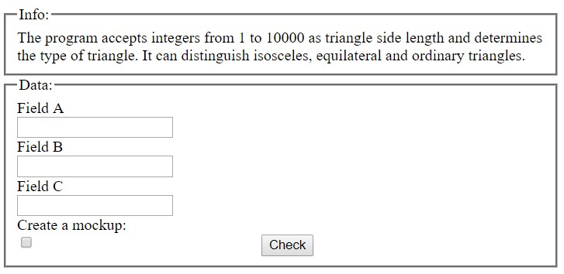

**Task 2 – Create smoke test cases**

Application receives from employees and saves the dates of the desired start and end of the vacation to the database

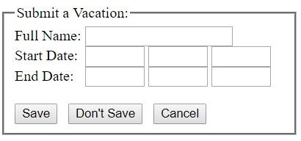

**Task 3 – Create bug reports**

Registration form of new user

